Stance Detection : Literature Review

**Paper 1 : Friends and Enemies of Clinton and Trump: Using Context for Detecting Stance in Political Tweets.**

Attempting to capture information related to domain knowledge, two concepts are defined : “enemies”

and “friends”.

Figure 1 shows an example of the relationships between the “friends” and “enemies” according to their political party, in this case the target of interest is Hillary Clinton.

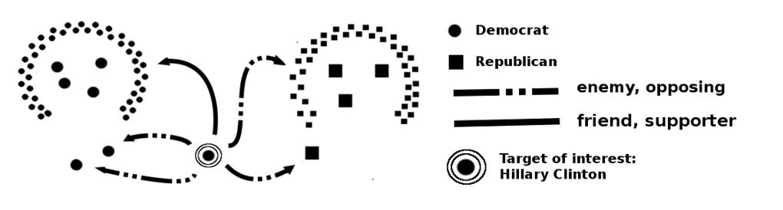

Three groups of features were considered: sentiment, structural, and context- based.

**Sentiment-based Features**

AFINN, Hu&Liu (HL), LIWC, DAL.

**Structural Features**

Hashtags, Mentions,Punctuation marks.

**Context-based Features**

Target of interest mentioned by name (targetByName)

Target of interest mentioned by pronoun (targetByPronoun)

Target’s party (targetParty)

Party colleague opposite (targetPartyColleagues)

Target’s oppositors party (targetsOppositors)

Nobody (nobody).

Based on all the above mentioned methods the datasets were trained and the results were obtained separately for Donald trump and Hillary Clinton. The ratio of tweets in favour,against and neither are calculated. Various participating systems were used for this purpose. The description about these systems are mentioned in the paper.

In this paper it is shown that including context-related information is crucial in order to improve the performance of stance detection systems. Experiments confirms that stance detection is highly dependent on the domain knowledge of the target in hand.They are not using either n-grams or any word-based representation, but the approach mainly relies on the context of the target in hand.

**Paper 2 : Stance Classification by Recognizing Related Events about Targets**

To predict stances considering these phenomena, they propose a classification method based on machine learning with the PRIOR-SITUATION and EFFECT of EVENT. They first annotate the labels PRIOR-SITUATION and EFFECT to the dataset.

The contributions of this paper are two-fold:

1. They propose the concepts of PRIOR-SITUATION and

EFFECT and annotate these labels to roughly 3,000 texts.

2. They confirm that the accuracy of stance detection can be

improved using these labels.

The proposed methods, which use PRIOR-SITUATION/EFFECT labels are described below. Using these labels,they aim to examine whether these labels are effective for FAVOR/AGAINST classification or not.

1. **PRIOR-SITUATION/EFFECT replaced n-gram**

In this approach the events are replaced either by %PRIOR-SITUATION% or %EFFECT% and it is classified if the event is positive or negative and based on this the stance is declared either in favour or against.

1. **Patterns around PRIOR-SITUATION/EFFECT feature**

Abstract patterns were calculated by various procedures. When applying the patterns to the input text, %X% is assumed to be PRIOR-SITUATION or EFFECT. Then, they activate %PositiveToX% when a pattern indicating a positive attitude in relation to %X% matches the input text, or we activate %NegativeToX% when a pattern indicating a negative attitude about %X% matches the input text. Consequently, there are four possible features conditional on %X% (%PositiveToPRIOR-SITUATION%, %PositiveToEFFECT%, %NegativeToPRIORSITUATION%, and %NegativeToEFFECT%).

1. **Sentiment polarity in PRIOR-SITUATION/EFFECT feature**

we calculate polarity score of PRIOR-SITUATION as greater than zero (i.e. positive), then we set this feature as %PositiveInPRIOR-SITUATION%. Consequently, there are four possible features conditional on polarity score (%PositiveInPRIOR-SITUATION%,

%PositiveInEFFECT%, %NegativeInPRIORSITUATION%, and %NegativeInEFFECT%). Note that, if polarity score of PRIOR-SITUATION/EFFECT is

calculated as zero, then this feature will be not activated.

**Paper 3: Twitter Stance Detection -**

**A Subjectivity and Sentiment Polarity Inspired Two-Phase Approach**

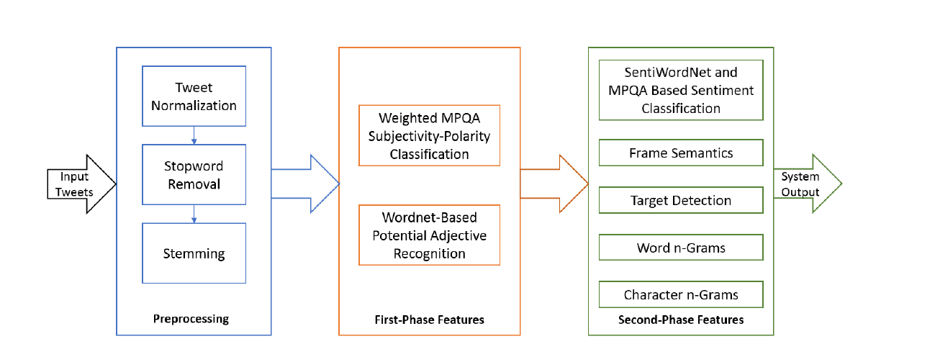

**Paper 3 : Topical Stance Detection for Twitter: A Two-Phase LSTM Model Using Attention**

a two-phase attention-embedded LSTM-based approach for detecting stance of tweets towards given topics.

* In the first phase, we perform subjectivity analysis of the tweets, using a combination of LSTM and attention embedding.
* In the second phase, we perform sentiment analysis on the subjective tweets, again using a combination of LSTM and attention embedding.
* At each phase, there are two components - a bidirectional LSTM and an attention mechanism. The bi-directional LSTM is used for feature encoding. The attention logic uses augmentation of the word embeddings withtarget topics, and subsequently passes it through a linear layer for computing attention of each word in the text in the context of the topic under consideration.

To compute attention, we augment the embedding of the constituent words with the average embedding of the target.The words within the sentence, that have the embeddings {z1, z2, ..., zm}

of dimension dz, are thus augmented with dimension dz ̃ (the dimension of z ̃), and each word gets a new embedding dimension of dz + dz ̃. This is processed as depicted in Figure below.

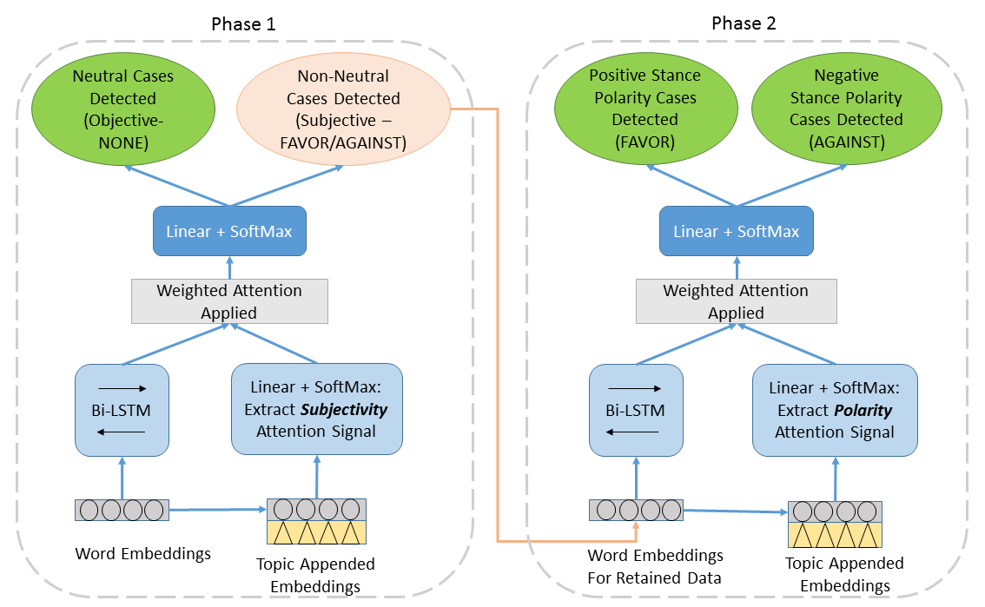

**Training the Models**

We try using both SGD (stochastic gradient descent) as well as Adam optimizers for experiments, and these yield similar effectiveness. We train our model using cross-entropy loss function. The loss of one phase is not propagated to the other.

**Data Description**

We perform data cleaning: net slang removal (for tweet normalization) using an online dictionary and stopword removal using a Stanford NLP resource for stopword removal